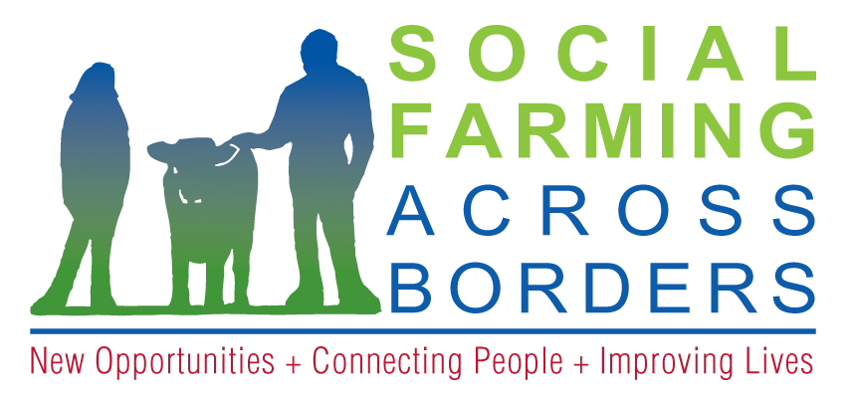
Laird House,
Drumshanbo, Co Leitrim,

Tel: +353 (0)71 964 1772
Email: socialfarming@ldco.ie
Web: www.socialfarmingacrossborders.org

DATA PROTECTION ACT CONSENT FORM

COMPUTERISED RECORDS
As soon as you complete an expression of interest the Social Farming Across Borders project create a computer record in your name. Information that we then collect, including information that you give us, is added to the record. You have the right, given by the Data Protection Act of 1988 to obtain a print out of your computer record at any time. We charge a fee of €5.00 Euro for each request.

You should address your request to:

Social Farming Across Borders
Laird House
Church Street
Drumshanbo
Co Leitrim

The information we record is used only for the following purposes:
- Processing applications
- Compiling statistical information to help us plan and improve our services
- Analysing information about applicants for other bodies such as Government Departments, and producing our own statistics for publication.

Personal information about you will be disclosed only in accordance with Leitrim Integrated Development Co Ltd (project partner) registration under the Data Protection Act. The purpose for which we hold information and the people to whom we may disclose it are listed in the Register of Data Controllers. This is a public register kept by the Office of the Data Commissioner at the Irish Life Building, Talbot Street, Dublin 1. (Phone 01- 874 8544), and you may inspect it free of charge.

To give you an example of disclosure: The Social Farming Project may be required to give participants names and other personal information to the funding body SEUPB. SEUPB in turn observes strict rules of disclosure that are registered with the Office of the Data Protection Commissioner.

NON COMPUTERISED RECORDS
Other information supplied and collected may also be disclosed to people and bodies from time to time. On request you can receive a list of disclosures.

DECLARATION
I have read and understand the above statement and consent to the use and disclosure of data and information as outlined above,

Name: ____________________________________________

Date: _____________________________________________

Witnessed by: _____________________________________

