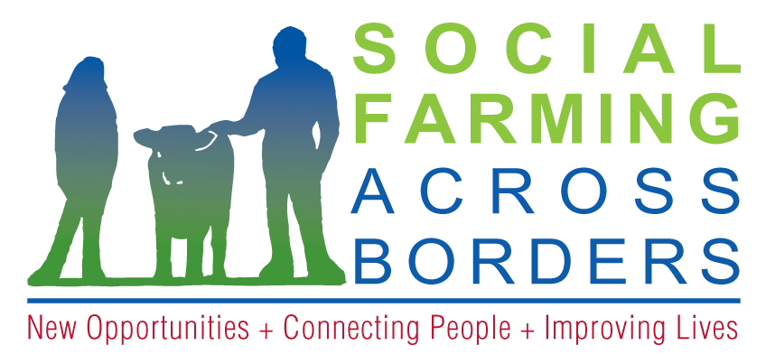

Laird House,

Drumshanbo, Co Leitrim,

Tel: +353 (0)71 964 1772

Email: socialfarming@ldco.ie

Web: www.socialfarmingacrossborders.org

**Project Update and Application Form for Farmers**

Thank you for returning an ‘Expression of interest Form’. The SoFAB Project is planning to commence piloting social farming on farms in February/March 2013. The pilots will be run on each farm through agreements reached between the farmers, people who avail of support and the relevant service agencies.

There are five steps to take in establishing the pilots and these are outlined below:

**Step 1: Collection of information from farm families with a view to matching People, Farmers and Agencies in each county.**

This information will be gathered through an Application Form (attached) which would need to be returned to us by **December 7th** at the project office. Based on the information collected about 40 farms across the region will be short-listed.

**Step 2: Shortlisting of farms from applications.**

The shortlist of 40 farms will then be contacted by the SoFAB Project to complete a Police / Garda Clearance process as a requirement for supporting vulnerable adults in both jurisdictions. The shortlisted farmers will also be asked to complete a community reference form.

**Step 3: The selection of twenty Pilot farms**

Twenty farms will be selected from the Project area – ten in Northern Ireland and ten in the border counties of the Republic of Ireland.

This will be based on matching up of the farms with people who use the services of agencies in a given local area. The established project committee will select the designated Pilot Farms. The 20 designated pilot farmers will be expected to complete a risk assessment on their farms with the support of the project (this will include farm visit(s) by the Project staff).

**Step 4: Training**

Training in the *essentials for social farming service delivery* will be provided to the 20 pilot farmers in advance of piloting. In addition to this training some small infrastructure works will be completed on farms to provide better access for those who will engage with social farming . This will be grant assisted and farm relief services will be available on request to provide cover on the farm at times of training.

**Step 5: Piloting**

The delivery of social farming services is planned to begin during Spring 2013. On each farm: 3 people who use services will visit the pilot farm on a weekly basis (the frequency of visits is flexible) for a total of 30 visits over the remainder of the year.

If you are still interested in becoming a pilot farm having considered the above steps, then please complete the enclosed SoFAB Pilot Farm Application Form.

Please note that engagement in Steps 1-3 above should not be understood as an offer to pilot with the SoFAB project. Finalisation of the pilot farms will be made based on the suitable matching of farms with people who use services and the service agencies available in an area.

Your time and commitment in completing the various steps within the project is very much appreciated.

Please feel free to contact me for any clarifications or assistance on the above.

Yours Sincerely



Paul Henry

SoFAB Project Coordinator.